ITSP - Institute Technical Summer Project:

If you had visited IIT Bombay anytime this summer, you would have noticed a large number of freshmen toiling away, day and night, at the labs in the institute. Now, you might wonder why students would forego their well-earned vacations to stay back in the scorching heat of Mumbai. ITSP is the reason why.

*What is ITSP?*

**Institute Technical Summer Projects (ITSP)**, a brainchild of the **Students’ Technical Activities Body (STAB),** is a platform provided to the freshmen of IITB in the summers to explore the "Techie" within them. Freshmen as teams of maximum four are required to submit an abstract of their dream project. These abstracts are verified by a team of helpful and dedicated seniors, suggestions are provided and projects are approved. Now comes the fun part. Approved freshmen teams get to work on their dream project for 45 days in the summer and the best part is - it doesn’t cost them a single rupee! The entire cost of the project is reimbursed by the institute.

*ITSP Schedule*

ITSP is kickstarted with an orientation in the 1st week of April after which project ideas are invited. Before finalizing the projects, 2-3 brainstorming sessions are organised where seniors are available to check the feasibility of the project ideas. Once all this is cleared, the actual implementation of projects starts. ITSP runs in two slots so as to smoothly accommodate the large number of freshmen who are a part of it. Every year, there is a group of enthusiastic mentors who donate their time to help the teams in implementing their projects. Review meets are held to verify the progress of the teams and to help them figure out solutions to the problems they are facing. Sessions are organised on common topics like Image Processing, Solidworks, Eagle etc. that are used in almost every other project.

*ITSP Showcase*

The exhibition of projects is held in August where the projects are judged by professors. Prizes are awarded to the Best Design, Best Research Project, Best Coding, Best Electrical Product, Best Mechanical project etc.

*Vision and mission*

IITs, being Institutes of “Technology”, are expected have an atmosphere conducive for pursuing interests in technical activities. ITSP is a step in this direction. If a student has a dream project in mind, then lack of resources, either monetary or intellectual, should not be a barrier in the path of achieving this dream. This is the driving principle behind ITSP and this is what motivates the STAB team to spend their summers in the institute. Emphasis is laid on building scalable products which could be potentially identified as disruptive innovations in a range of fields. This year, two major elements of ITSP were: 1). Product development aspects i.e. design and aesthetics 2). Associating their project with some real life world problem so that project can be implemented after its successful completion and hence can be of some use to society and India industry.

Warm Regards,

--

Rahul Prajapat

Overall Coordinator

Students' Technical Activities Body

IIT Bombay

9892945399

stab-iitb.org

Selected projects

In the fourth successful installment of ITSP, there were a bunch of innovative projects which aimed to solve prevalent problems with a new approach. Here are a few -

**Intelligent Walking Stick for the blind:**

* Detects obstacles using ultrasonic sensors
* Generates audio commands to guide the user so as to avoid obstacles
* Easily attachable to a walking stick
* <http://itsp.stab-iitb.org/projects/?id=1RE22>

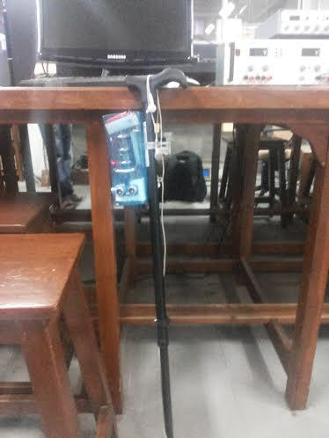

**Gesture Talk Project for the dumb:**

* Glove that converts gestures into words that are displayed on a computer screen
* Each gesture is a combination of finger movements and corresponds to a letter
* An improved version is being envisioned which could convert gestures to speech
* <http://itsp.stab-iitb.org/projects/?id=1RE16>

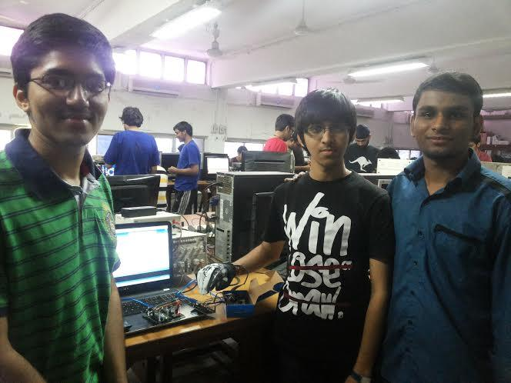

**Drishti : Automatic Book Reader for blind People:**

* Takes images of pages and uses image processing and text-to speech conversion methods to read out the text aloud
* Could potentially end the need for special books for the blind and make all kinds of books accessible to them
* http://itsp.stab-iitb.org/projects/?id=1RE14

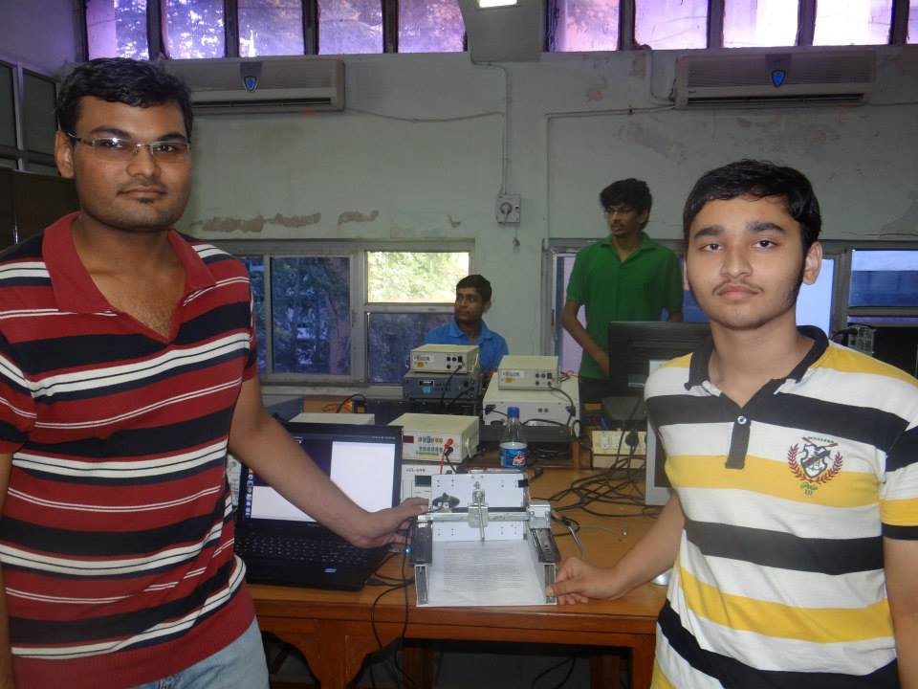

**Blaze Skaters, easily portable shoes cum skates with remote controlled braking system, speedometer, odometer, obstacle sensing**

* Lightweight skates which can be easily carried in your backpack (usually skates are pretty heavy)
* They have a handheld braking mechanism which is helpful to new learners and also can tell you the speed at which you’re skating and if there are any obstacles you need to avoid
* http://itsp.stab-iitb.org/projects/?id=1RE10

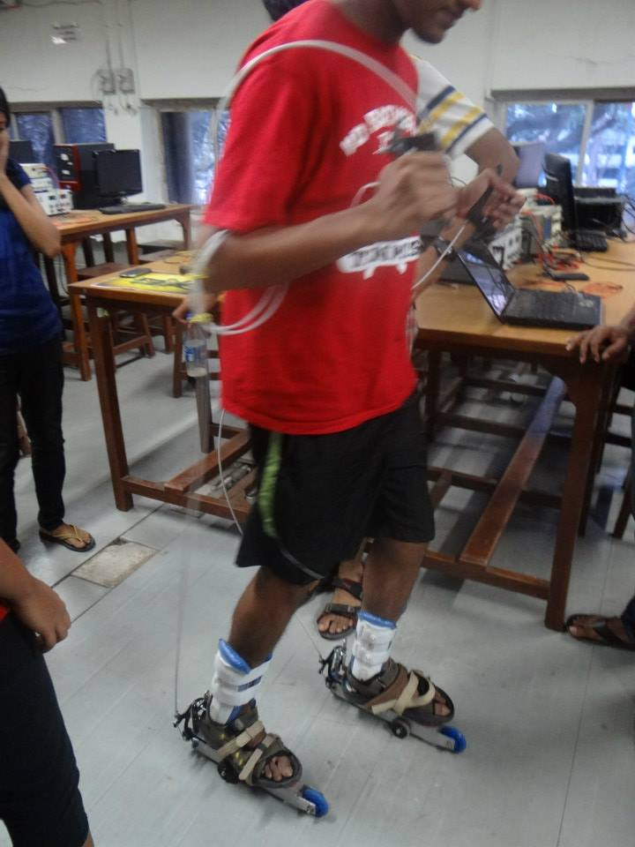

**Sound Following Robot : Vision for blind using ultrasonic sensors**

* Industrial design project, can be used in security surveillance areas
* Provides artificial guidance to the visually impaired
* Ultrasonic sensors are used to detect the presence of obstacles so that a suitable path can be found and communicated to the user in the form of voice commands
* http://itsp.stab-iitb.org/projects/?id=1RE18

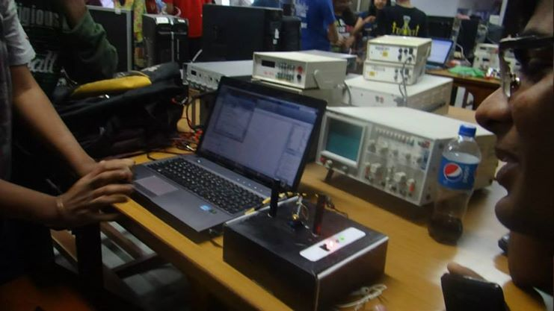

**Monkey Pole Climbing Robot, Industrial design project, can be used in security surveillance areas**

* Robot which can climb over pole with bends
* Has applications in areas like military operations,fire fighting operations,repairing electric poles,spying purposes etc
* http://itsp.stab-iitb.org/projects/?id=1RE28

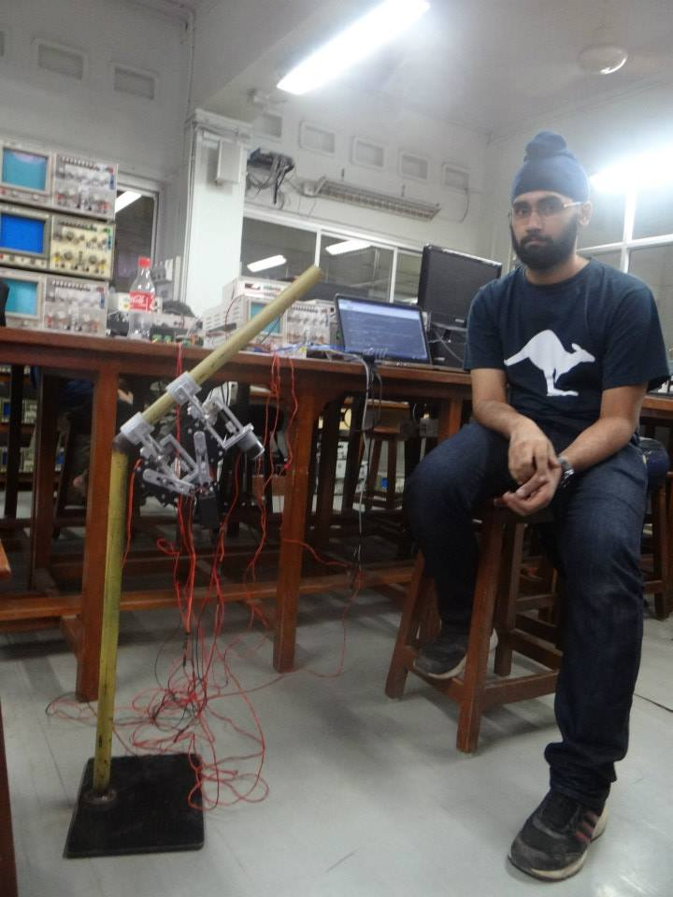

**Holographic Keyboard, famous technique “sixth sense” based project**

* Inspired by the “Sixth Sense” technology pioneered by Pranav Mistry
* Any surface can be converted into a virtual keyboard using this device
* <http://itsp.stab-iitb.org/projects/?id=1RE36>
* http://itsp.stab-iitb.org/projects/?id=1RE42

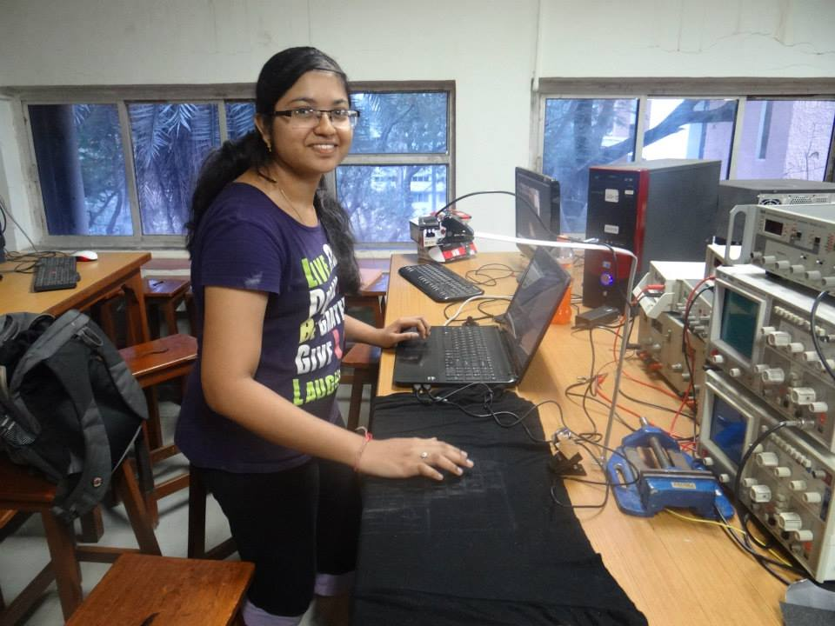

**Invisible Braille Reader**

* Portable device which would help blind people read books
* Consists of a hand glove with mini actuators present at the fingertips which would give a vibrotactile Braille impression on the respective fingers of the blind person
* Aims to eliminate the need for Braille books which are expensive and not easily available
* <http://itsp.stab-iitb.org/projects/?id=1RE35>

**Surveillance Bot**

* Consists of a camera mounted on a surveillance bot
* This bot is capable of attaching on any surface that is detachable
* The device can move on any surface like wall, floor, or ceiling using vacuum pump and suction cups
* <http://itsp.stab-iitb.org/projects/?id=1RE13>
* 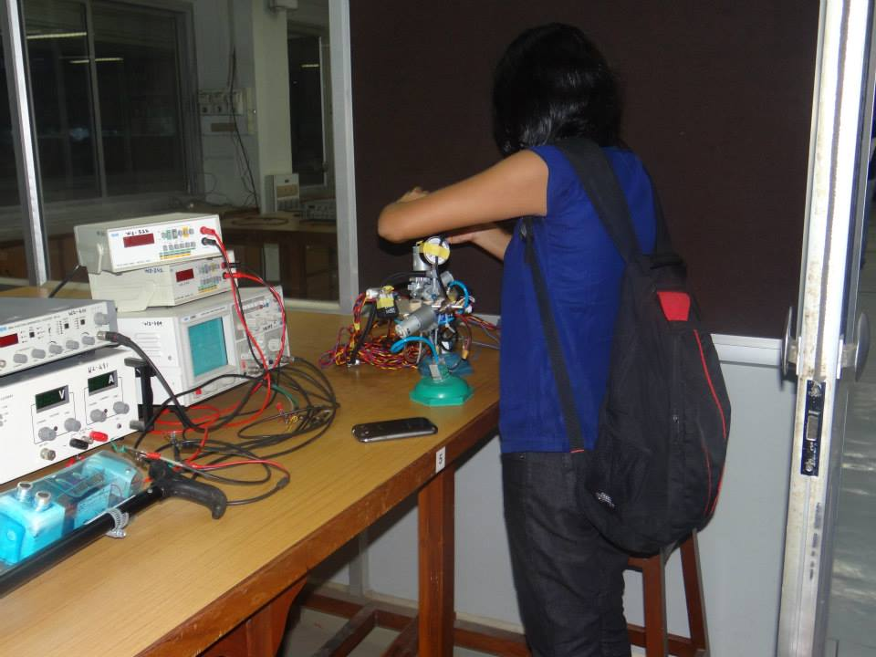

**H-SQUARE : Hovercraft + Helicopter**

* Hovercraft which has the capability to change into a helicopter
* Has unique applications in the field of security surveillance
* The operation of this this hovercraft requires only one motor
* http://itsp.stab-iitb.org/projects/?id=1AR10

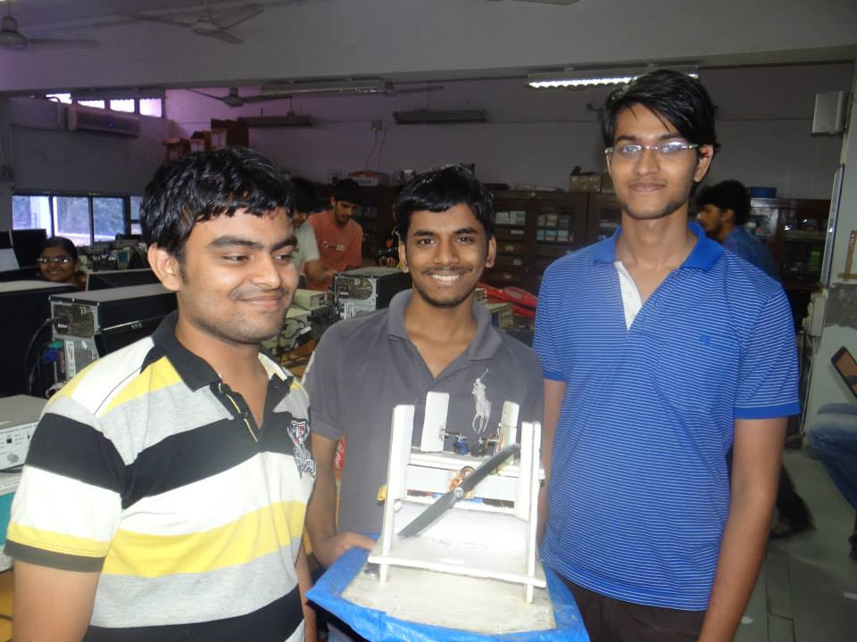

**Differential Tracking**

* Minimising the error of the GPS by using more than one GPS module in an RC plane and real time tracking of the planes path
* This is **extra 300 RC** scale model of the plane, which will carry multiple GPS modules
* The plane is made of **balsa wood** and **high performance components** are used to test the tracking potentials of the plane in all three dimensions
* https://www.youtube.com/watch?v=E0AYdtG4ezQ
* http://itsp.stab-iitb.org/projects/?id=1AR02

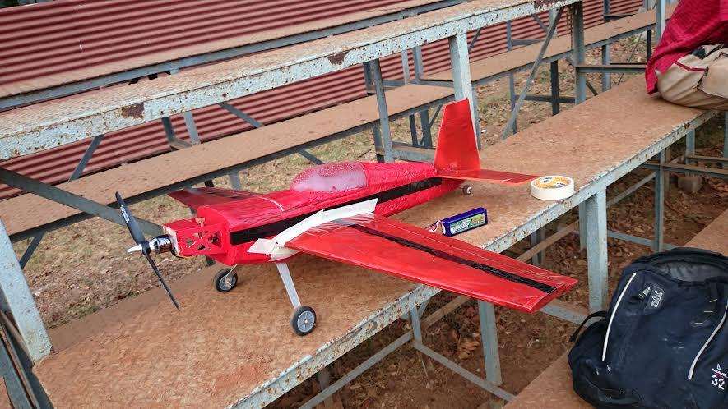

**Mobile Controlled RC Plane**

* An RC plane which is controlled using an Android mobile application
* Now this can be controlled using both transmitter and android phone
* http://itsp.stab-iitb.org/projects/?id=1AR0